Oliver Cheng
Professor Sheng
Data 485
5 May 2025
Project 4: Reddit Reflection Paper
At the beginning of the project we had a lot of difficulty with scraping the data from Reddit, and also figuring out a way to approach the questions using data science, as the questions were a lot more sociological. For this particular project, I was tasked with scraping the data. Originally, I thought about comparing the top 1000 comments from the top post in 4 of the subreddits (MadeMeSmile, AskReddit, NoStupidQuestions, and MildlyInfuriating), but then I realized that it would probably be a better idea to scrape the top 100 posts from each subreddit, and collect the top 50 comments from each. This approach seemed a lot better, and made the analysis of the data more interesting.
To analyze the data, the three of us agreed that we should use various NLP techniques that we have learned this semester in order to analyze the data. The initial analysis was done using SpaCy to compare the top 10 words across the comments in each subreddit. 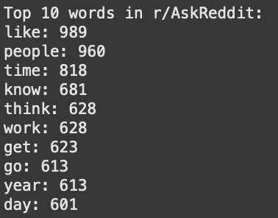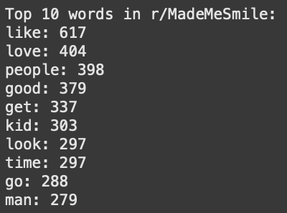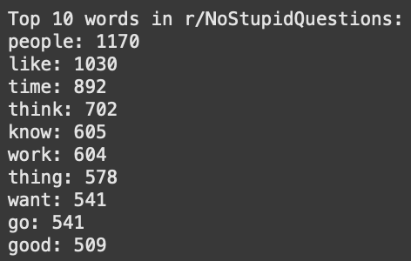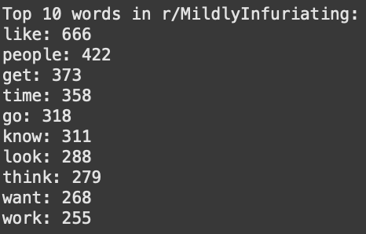
This did not yield any useful information that we were hoping for to answer any of the questions. The only difference in the words was that MadeMeSmile had words that were more relevant to the actual title of the sub, like love and kid, while the other three subs were more general, but that is likely due to the fact that the sub is more focused around one theme; to make people smile, while the other ones were more general.
We then figured that it would be more useful to compare the top 20 distinct words in each subreddit. The top 20 words across all of the subs revealed more about the nature of each subreddit. MadeMeSmile had words that were more quirky and wholesome, while MildlyInfuriating had words that were a lot more negative and irritating. For example, MadeMeSmile has words like “Moo” and “Deng” that come from comments about the cute baby hippo, while MildlyInfuriating had words like “humidity”, “bitching”, and “moldy”. AskReddit was more general and about general curiosity, while NoStupidQuestions was a little more crazy and wilder. However, these results were not not relevant to answering the question: what makes a distinct community?
The next analysis we did was utilize VADER to run sentiment analysis. These results were a little bit more surprising.
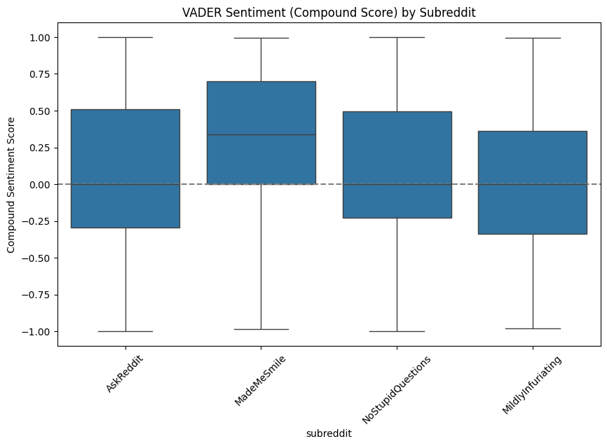
AskReddit had the widest range between positive, and negative sentiments, but the overall compound was pretty neutral. MadeMeSmile was the most positive, as we expected, and NoStupidQuestions was the most neutral. What surprised me though was I was expecting MildlyInfuriating to be significantly more negative than the rest, similar to the inverse of MadeMeSmile. My suspicions about why MildlyInfuriating was more neutral than we expected was likely due to the moderators of the sub deleted the really bad comments and posts.
For the final analysis we attempted to use topic analysis, but struggled to effectively create a visual representation of the results.
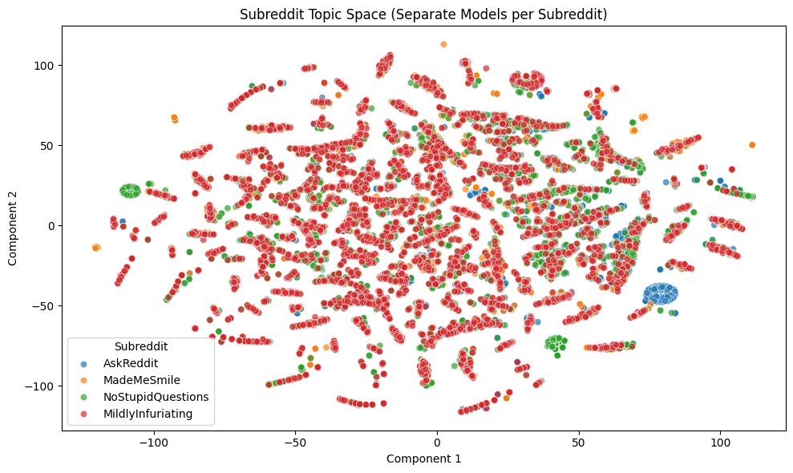
These results were the most surprising. We expected MadeMeSmile to be the closest together in clustering, and closest in topic subject of the comments, but were shocked that it was the most dispersed. The other three were also very dispersed, but there were clear clusters of topics where the comments from the top 8 posts were similar.
Overall, I think that these subreddits tell us more about Reddit as a social media app as a community taken as a whole, rather than the communities about the individual subreddits. There were several users who commented in multiple subreddits. It seems that the reason for what makes reddit a distinct community is the fact that there are several subreddits that allow people to either feel good or to vent through the interactions between the various subreddits. It allows people to find a place where they can relate to other people and share their feelings in a unique way. What makes Reddit a unique community is the fact that we were surprised at how neutral the overall sentiment was across the four subreddits we analyzed. This may be due to the fact that the moderators of the subreddits take down the very negative posts or comments, because they may violate the policies of the subs. Another thing that makes the subreddits unique is the wide range of topics in posts and comments within each subreddit, MakeMeSmile being the most, and the other three being fairly similar. Across the four subreddits, there wasn’t much conflict as the sentiment was fairly neutral across the board. As previously mentioned, this is likely due to the culture of Reddit, where people are either more likely to agree with each other and participate in productive conversations, or that the moderators take down posts that are in violation of the rules, leaving only comments that are more or less similar to each other. The final question we answered was: what makes people want to join these communities? Because Reddit is a pseudonymous platform, people who use the platform are likely more honest due to the fact their personal information is hidden. This shows in the analysis because the absurdity of the questions for NoStupidQuestions and AskReddit appear in the top 20 distinct word analysis. People aren’t worried about them being judged by the other members in the community, and allow for more genuine conversations. It also allows the users to interact positively with one another to discuss topics of similar interest between one another.

